**Assignment – Case Study-1 OYO Business**

By Afreen Sultana A

create database OyoBusiness;

use OyoBusiness;

create table OYO_city (

hotel_id INT PRIMARY KEY,

city VARCHAR(50)

);

create table OYO_sales (

booking_id INT PRIMARY KEY,

customer_id INT,

status VARCHAR(20),

checkin DATE,

checkout DATE,

number_of_rooms INT,

hotel_id INT,

amount DECIMAL(10, 2),

discount DECIMAL(10, 2),

date_of_booking DATE,

FOREIGN KEY (hotel_id) references OYO_city(hotel_id)

);

insert into OYO_city values (56, 'Bangalore');

insert into OYO_city values (45, 'Delhi');

insert into OYO_city values (16, 'Gurgaon');

insert into OYO_city values (14, 'Kolkata');

insert into OYO_city values (15, 'Pune');

insert into OYO_city values (10, 'Mumbai');

insert into OYO_city values (7, 'Chennai');

insert into OYO_city values (18, 'Hyderabad');

insert into OYO_sales values

(1, 201, 'stayed', '2025-07-19', '2025-07-20', 1, 56, 2000, 100, '2025-07-19'),

(2, 202, 'stayed', '2025-07-22', '2025-07-23', 1, 45, 2500, 200, '2025-07-20'),

(3, 203, 'stayed', '2025-02-21', '2025-02-22', 1, 16, 2300, 150, '2025-02-19'),

(4, 204, 'stayed', '2025-03-01', '2025-03-02', 1, 14, 1800, 100, '2025-02-28'),

(5, 205, 'stayed', '2025-08-01', '2025-08-03', 2, 15, 3000, 300, '2025-06-25'),

(6, 206, 'Cancelled', '2025-01-11', '2025-01-12', 1, 10, 2800, 150, '2025-01-01'),

(7, 207, 'No Show', '2025-07-20', '2025-07-21', 1, 16, 2200, 100, '2025-07-20'),

(8, 208, 'Cancelled', '2025-07-22', '2025-07-23', 1, 7, 2100, 100, '2025-07-21');

8th Question is repeated

**----1and 8. Average room rate of different cities----**

select c.city, AVG(s.amount) as average_room_rate from OYO_sales s inner join OYO_city c on s.hotel_id=c.hotel_id where s.status='stayed' group by c.city;

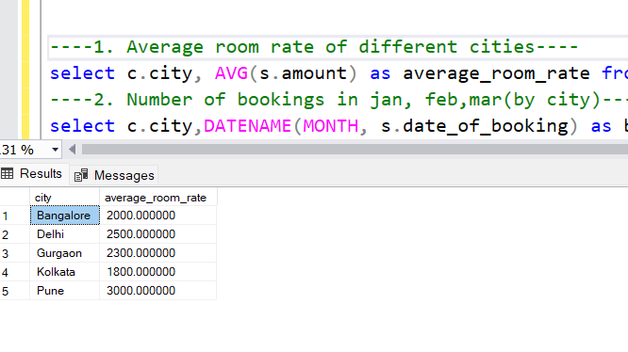

**----2. Number of bookings in jan, feb,mar(by city)----**

select c.city,DATENAME(MONTH, s.date_of_booking) as booking_month, COUNT(*) AS total_bookings from OYO_sales s INNER JOIN OYO_city c ON s.hotel_id = c.hotel_id where MONTH(s.date_of_booking) IN (1, 2, 3) group by c.city, DATENAME(MONTH, s.date_of_booking);

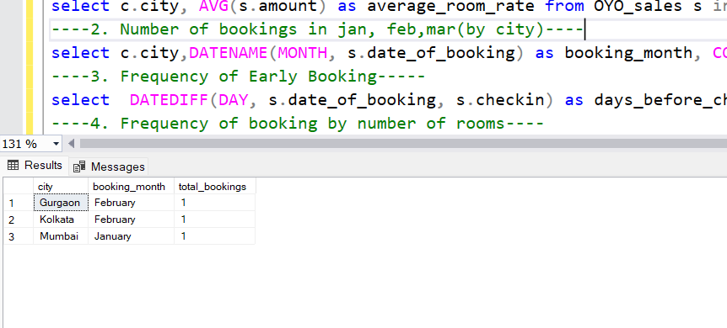

**----3. Frequency of Early Booking-----**

select DATEDIFF(DAY, s.date_of_booking, s.checkin) as days_before_checkin, COUNT(*) AS booking_count from OYO_sales s group by DATEDIFF(DAY, s.date_of_booking, s.checkin);

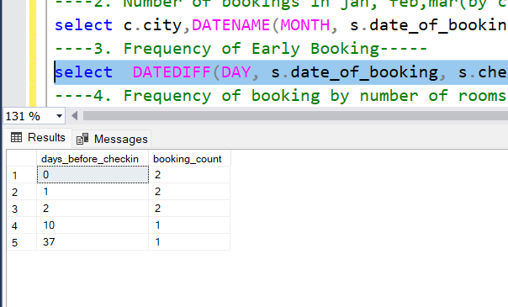

**----4. Frequency of booking by number of rooms----**

select number_of_rooms, COUNT(*) as frequency from OYO_sales group by number_of_rooms;

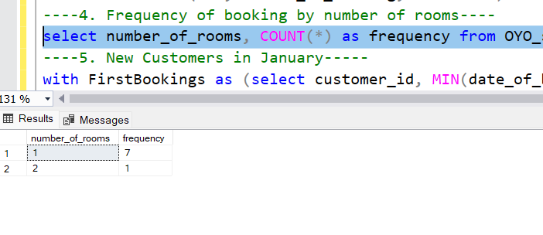

**----5. New Customers in January-----**

with FirstBookings as (select customer_id, MIN(date_of_booking) as first_booking_date from OYO_sales group by customer_id) select COUNT(*) as new_customers_in_jan from FirstBookings where MONTH(first_booking_date) = 1;

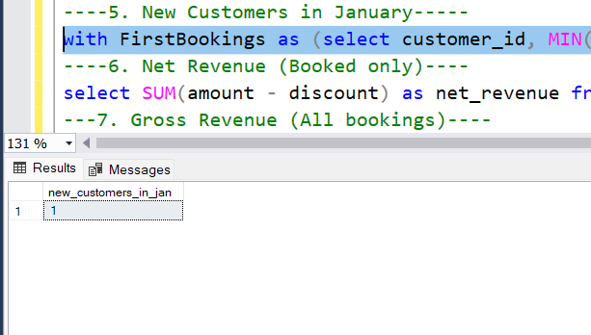

**----6. Net Revenue (Booked only)----**

select SUM(amount - discount) as net_revenue from OYO_sales where status = 'stayed';

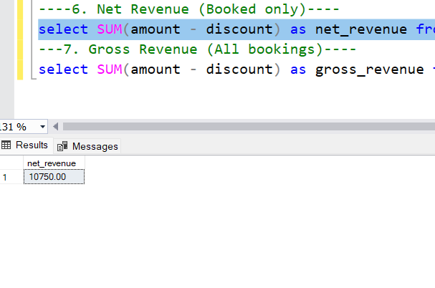

**---7. Gross Revenue (All bookings)----**

select SUM(amount - discount) as gross_revenue from OYO_sales;

